1. Peanut Butter:

Psuedo code:

start:

gather the ingredients peanuts, sugar or jaggery, pan and bowl.

add the peanuts to pan and rinse the peanuts.

after rinsing the peanuts, add peanuts and sugar or jaggery to jar.

keep in jar until it becomes creamy.

after it is creamy keep in bowl and have it.

end.

Flow chart:

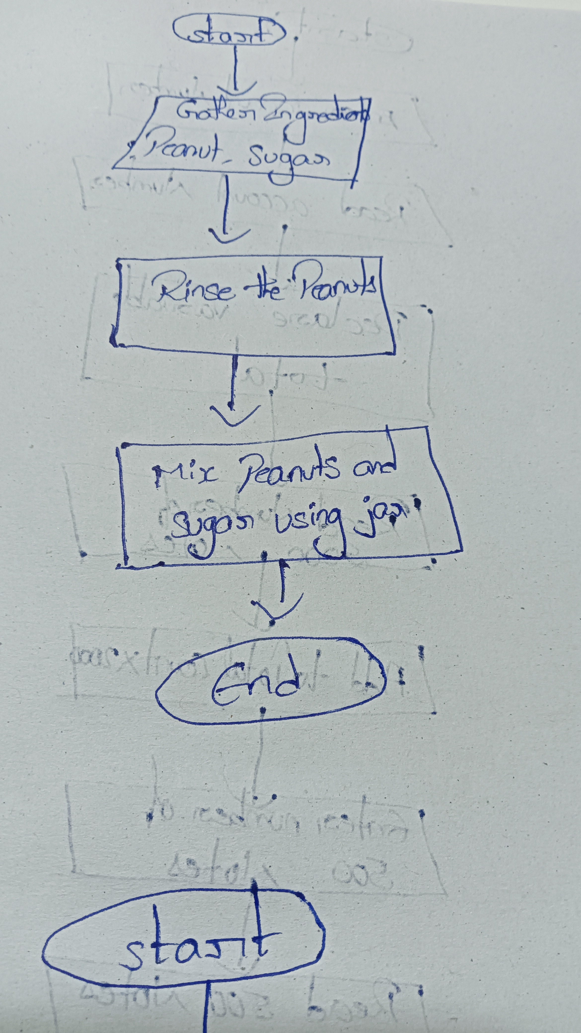

3. Bank customer:

start:

ask the customer for bank account number.

read the account number.

Declare a total variable to store value of jar of coins.

ask the customer to enter number of 2000 rupees notes.

read the number of notes.

multiply number of notes with 2000 and add to total.

ask the customer to enter number of 500 rupees notes.

read the number of notes.

multiply number of notes with 500 and add to total.

ask the customer to enter number of 200 rupees notes.

read the number of notes.

multiply number of notes with 200 and add to total.

ask the customer to enter number of 100 rupees notes.

read the number of notes.

multiply number of notes with 100 and add to total.

ask the customer to enter number of 5 rupees coins.

read the number of coins.

multiply number of coins with 5 and add to total.

ask the customer to enter number of 2 rupees coins.

read the number of coins.

multiply number of coins with 2 and add to total.

ask the customer to enter number of 1 rupee coins.

read the number of coins.

multiply number of coins with 1 and add to total.

Display the total to the customer.

end.

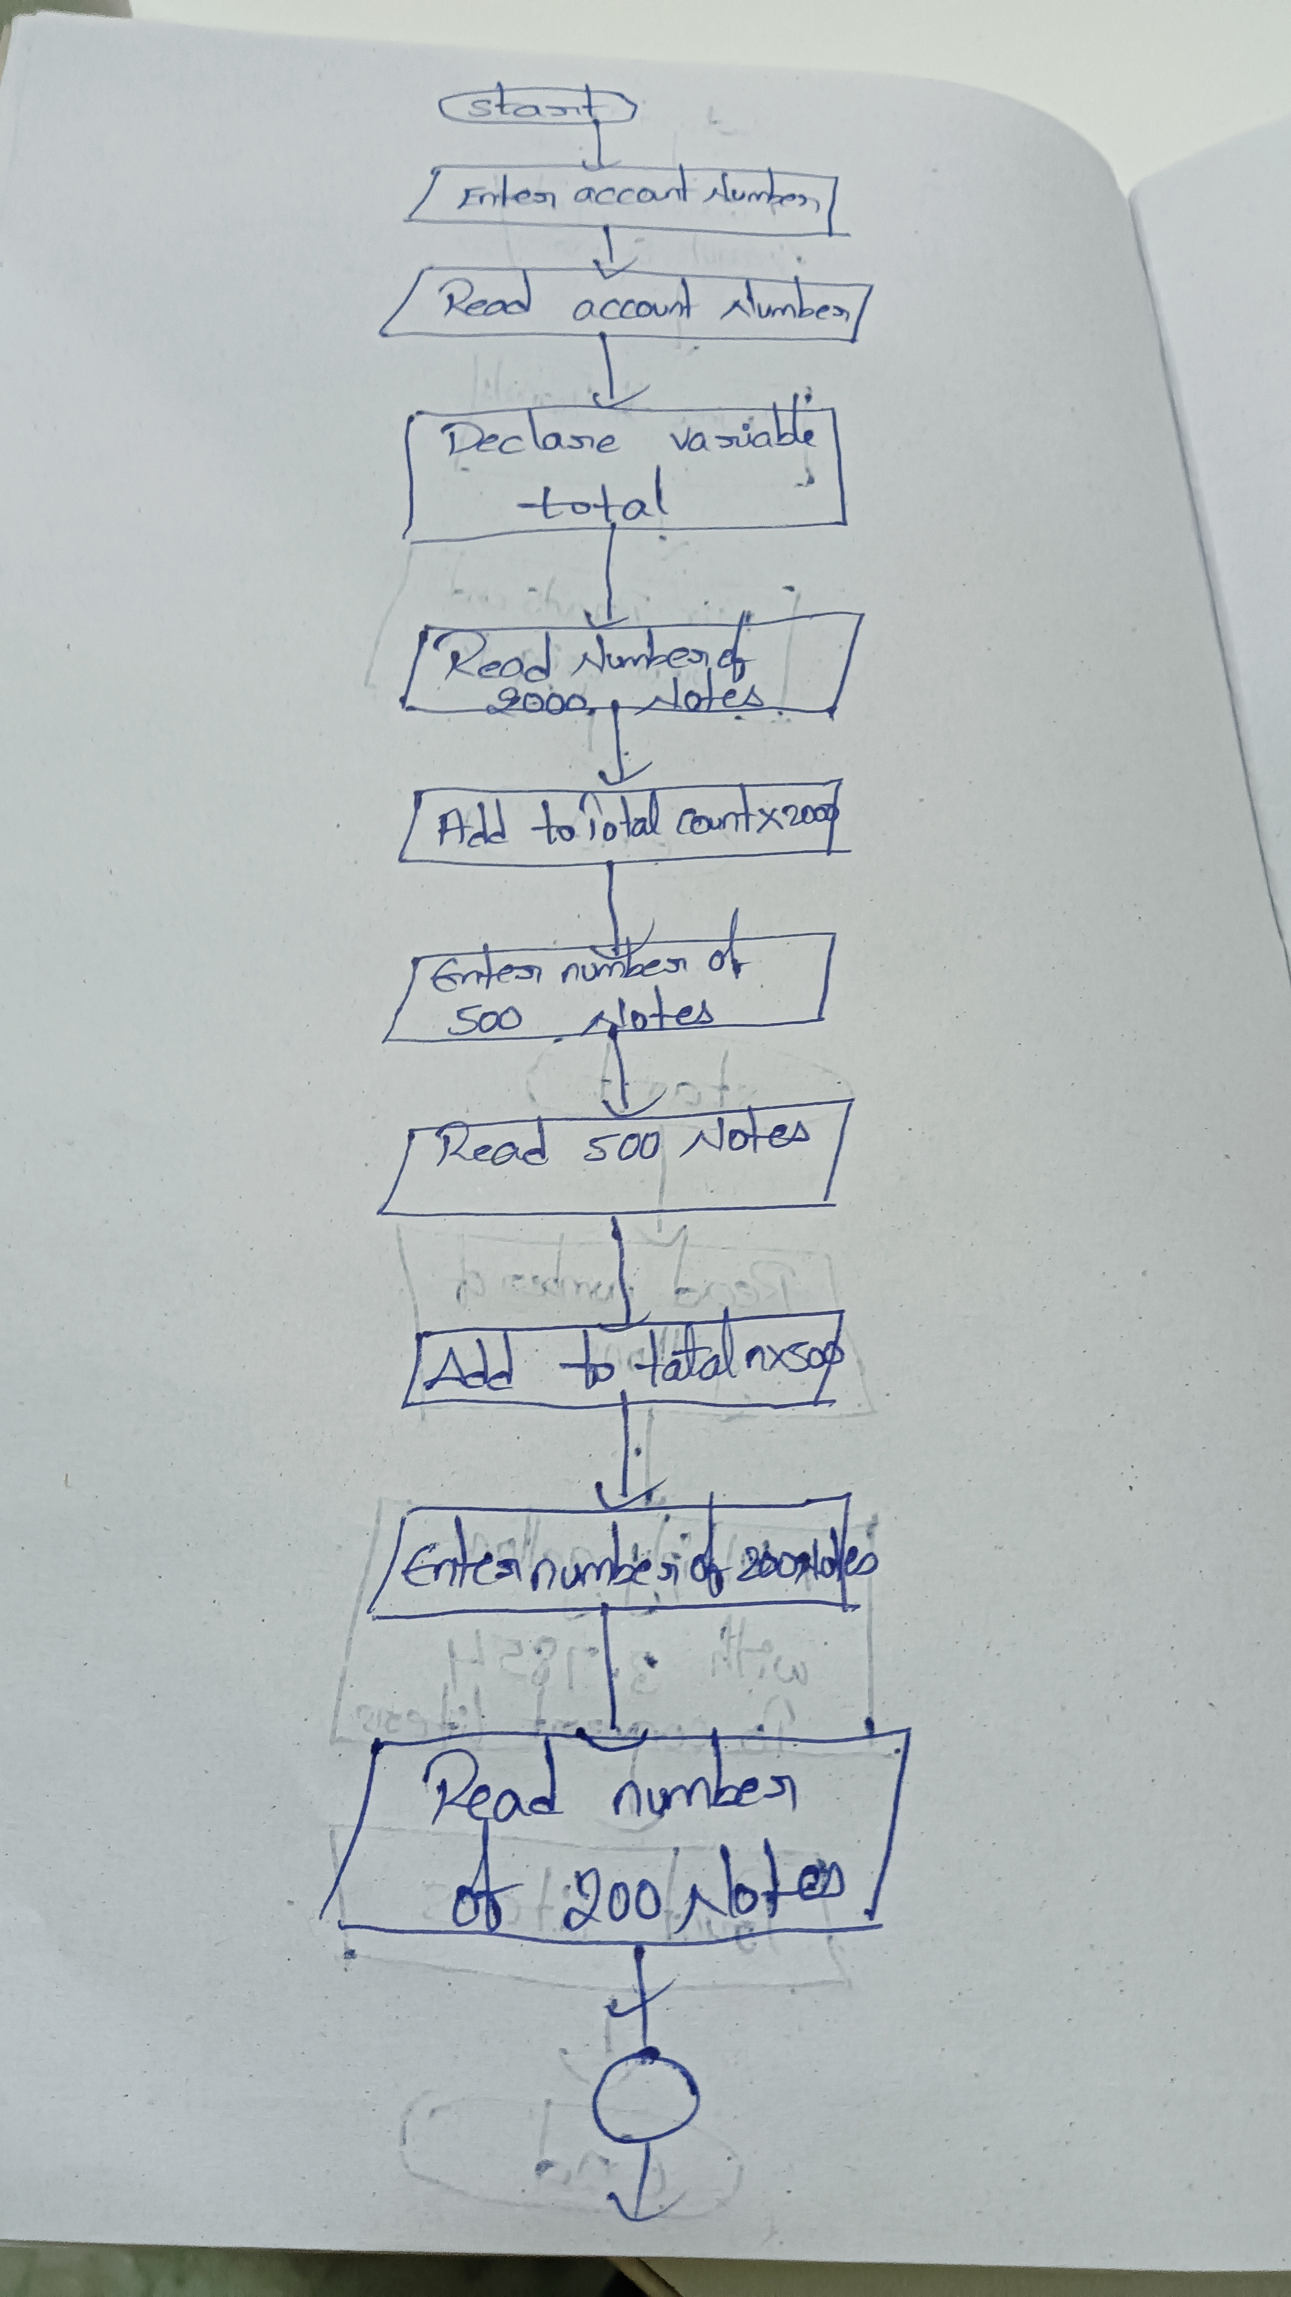

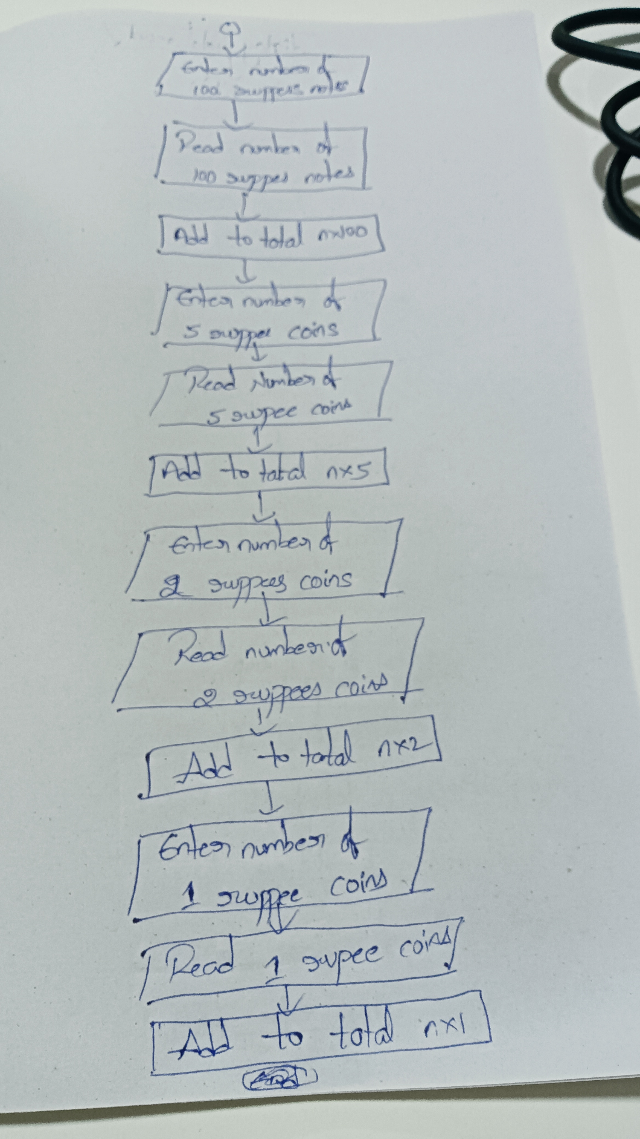

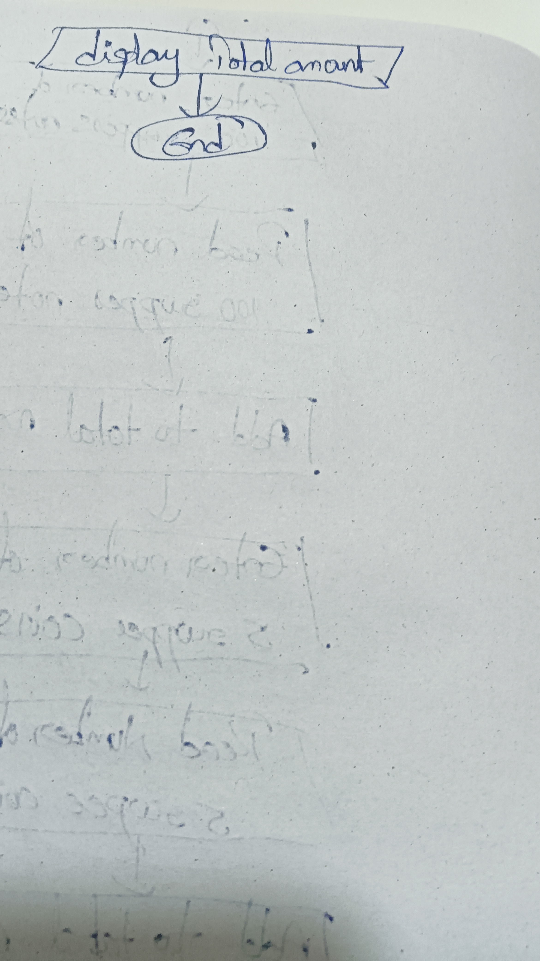

4. Gallons to liter

start:

ask the user to enter number of gallons.

read the gallons.

convert gallons to liters by multiplying number of gallons with 3.7854.

display the liters.

end.

Flowchart:

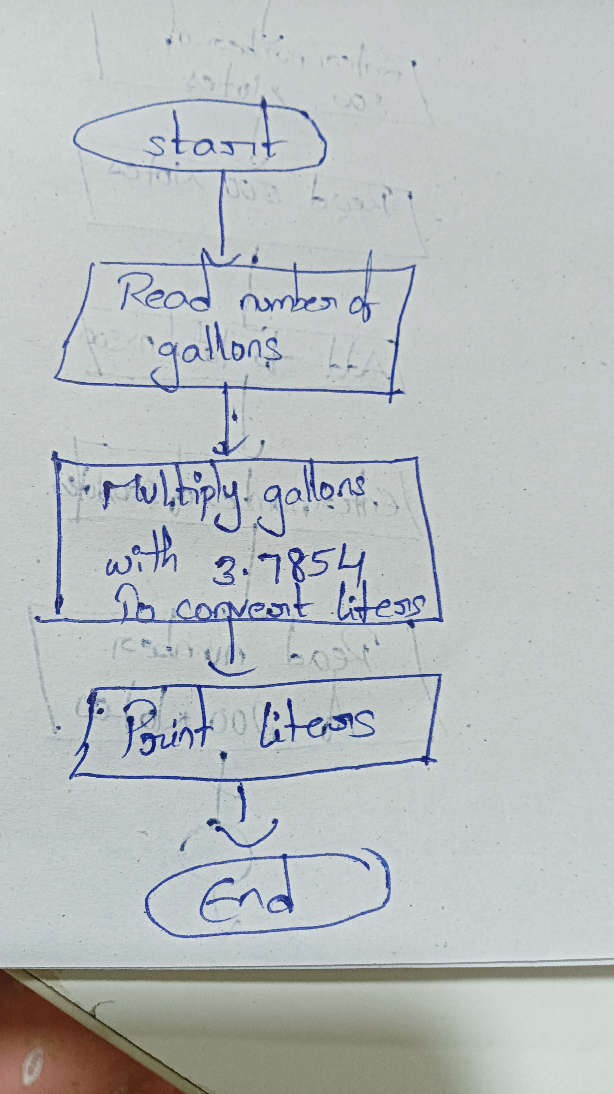

5. Restuarant:

start:

declare total variable to store total purchases for the day.

ask the chef to enter quantity of apples.

read the quantity.

ask the chef to enter price of apples.

read the price.

multiply quantity with price and add to total.

ask the chef to enter quantity of oranges.

read the quantity.

ask the chef to enter price of oranges.

read the price.

multiply quantity with price and add to total.

ask the chef to enter quantity of bananas.

read the quantity.

ask the chef to enter price of bananas.

read the price.

multiply quantity with price and add to total.

ask the chef to enter quantity of mangos.

read the quantity.

ask the chef to enter price of mangos.

read the price.

multiply quantity with price and add to total.

ask the chef to enter quantity of tomatoes.

read the quantity.

ask the chef to enter price of tomatoes.

read the price.

multiply quantity with price and add to total.

display the total.

end.

Flow chart:

